Online Course Registration System
SW301 - Course Project – Phase 4 - Implementation
Ahmed Wael 202201415
Ahmed Sameh 202202151
Seif Eldin 202201510

Focuses on translating the system design into a working Java prototype.
The goal is to demonstrate the core functionality of the Online Course Registration System using a console-based interface while following object-oriented design.

Development Environment
- Programming Language: Java
- IDE: IntelliJ – visual studio code
- Paradigm: Object-Oriented Analysis and design
- Version Control: GitHub Repository
- Execution Mode: Console-based

System Architecture
The system implements the core design classes. The classes are grouped into logical packages:
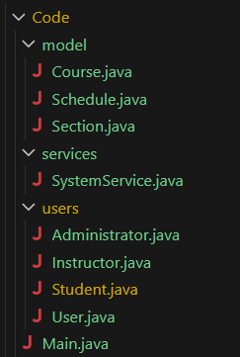

Implemented Core Classes
Users
- User (Abstract)
- Student
- Instructor
- Administrator
Purpose:
- Maintain inheritance
- Avoid duplication
- Support role-based logic

Academic Classes
- Course
- Section
- Semester (concept represented indirectly)
- Schedule

Registration Logic
Registration is implemented functionally through:
- Section → enrollStudent()
- Schedule → addSection()

Implemented Features
Student Features
Students can:
- Login
- View available courses and sections
- Register for courses
- Ensure:
  - Capacity validation
  - No duplication
- View their schedule
Instructor Features
Instructors can:
- View their assigned course sections
- View enrolled students per section
- Monitor enrollment status

Administrator Features
Administrators can:
- Add new courses
- Add new sections
- Add Users (Student, instructor, administrator)
- Assign instructor
- Manage academic structure
This supports:
- Academic planning
- Institutional control

Console-Based Interaction
Main Menu
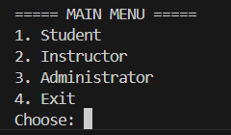
Student Menu
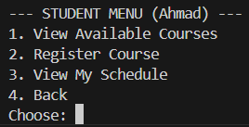
Instructor Menu
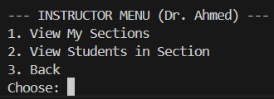
Administrator Menu
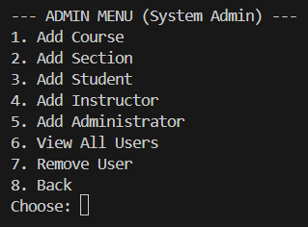
Sample Console Output
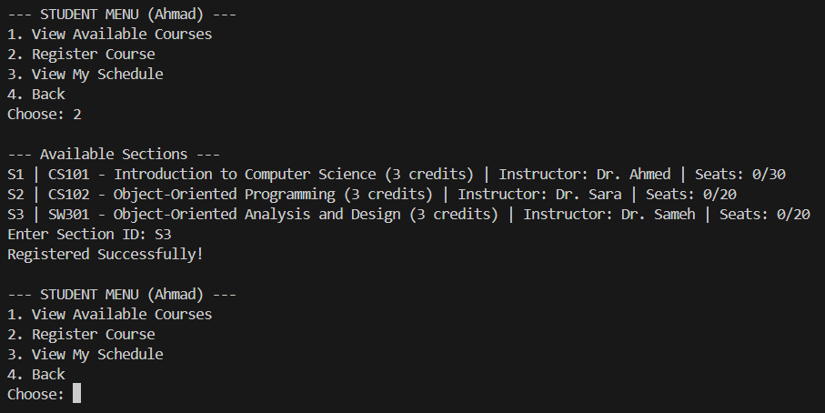
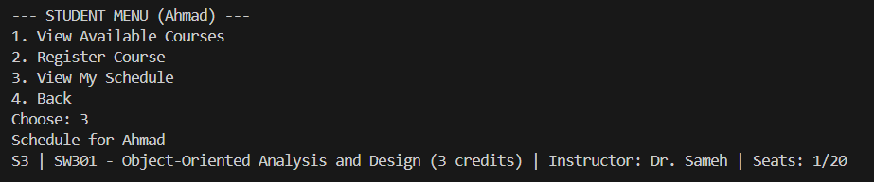
GitHub Repository
https://github.com/shadow9-1-1/Online-Course-Registration.git

